# **Payment Plan Sign-Up Instructions**

**Please Note:**

**Debit/Credit Card Payment Plan for 2025-26 is available for registration now!**

**Payment Plan is available only for the $1,550 fee, not the $250 non-refundable deposit.**

1. Log onto your Parent PowerSchool account and select Student Fees in the top left corner.

1. Click on the cart icon in the top right corner of the screen.

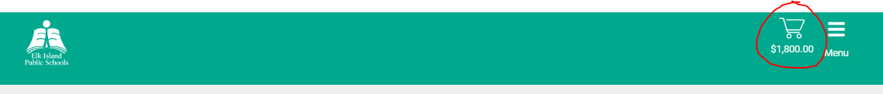

1. On the Checkout page, click **Payment Plan** under Payment Options.  
   A screen shot of a payment plan

   AI-generated content may be incorrect.
2. In the next window, add a debit or credit card (Visa or Mastercard) to the account as the payment method for the plan by clicking **Manage Saved Card.**

1. Enter your card details and click **Add Method**. Please note that if you have multiple cards saved, there is no priority selection in the card selected to process a payment. We recommend using a single card in your account if you prefer to have a specific card charged.

**\*\*\*If your card is expiring during the payment plan, or the saved card unexpectantly becomes inactive, you will need to enter the new / replacement card information and delete out the expired / inactive card information at that time, otherwise instalment payments will no longer be processed.\*\*\***

1. Review the details and instalments, then finally click **Create Plan** to confirm.

Payments of $155 will then be charged to the card on file on each of the listed dates.

